
SEMESTER ONE

YEAR 11

MATHEMATICS METHODS

Unit 1

2015

Section One
(Calculator–free)

Name: _________________________________

Teacher: _______________________________

TIME ALLOWED FOR THIS SECTION

Reading time before commencing work: 5 minutes
Working time for section: 50 minutes

MATERIAL REQUIRED / RECOMMENDED FOR THIS SECTION

To be provided by the candidate
Standard items: pens, pencils, pencil sharpener, highlighter, eraser, ruler.

IMPORTANT NOTE TO CANDIDATES

No other items may be taken into the examination room. It is your responsibility to ensure that you do not have any unauthorised notes or other items of a non–personal nature in the examination room. If you have any unauthorised material with you, hand it to the supervisor before reading any further.

To be provided by the supervisor

Question/answer booklet for Section One.
A formula sheet which may also be used for Section Two.
Structure of this examination

 | Number of questions available | Number of questions to be answered | Working time (minutes) | Marks available | Percentage of exam
Section One  Calculator—free | 8 | 8 | 50 | 50 | 35
Section Two  Calculator—assumed | 11 | 11 | 100 | 100 | 65
Total marks |  |  |  | 150 | 100

Instructions to candidates

1. The rules for the conduct of this examination are detailed in the Information Handbook.
Sitting this examination implies that you agree to abide by these rules.

2. Write your answer in the Question/Answer booklet.

3. You must be careful to confine your responses to the specific questions asked and to
follow any instructions that are specific to a particular question.

4. Spare pages are provided at the end of this booklet. If you need to use them, indicate
in the original answer space where the answer is continued i.e. give the page number.

5. Show all your working clearly. Your working should be in sufficient detail to allow your
answers to be checked readily and for marks to be awarded for reasoning. Incorrect
answers given without supporting reasoning cannot be allocated any marks. For any
question or part question worth more than two marks, valid working or justification is
required to receive full marks. If you repeat an answer to any question, ensure that you
cancel the answer you do not wish to have marked.

6. It is recommended that you do not use pencil, except in diagrams.

7. The Formula Sheet is not to be handed in with your Question/Answer booklet.

1. (5 marks)
(a) Simplify, leaving answer with positive integers (2)
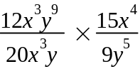

(b) Many fruit picking jobs are paid by the number of buckets of fruit picked each day.
For tomatoes, the rate is $1.50 per bucket.
Explain why this method of payment is an example of direct proportion. (1)

(c) The variables a and b are inversely related. If a = 5, then b = 4.
Determine a when b = 2. (2)
2. (11 marks)
The points P (2, 8), Q (10, 2) and R (4, 12) are shown in the diagram below.
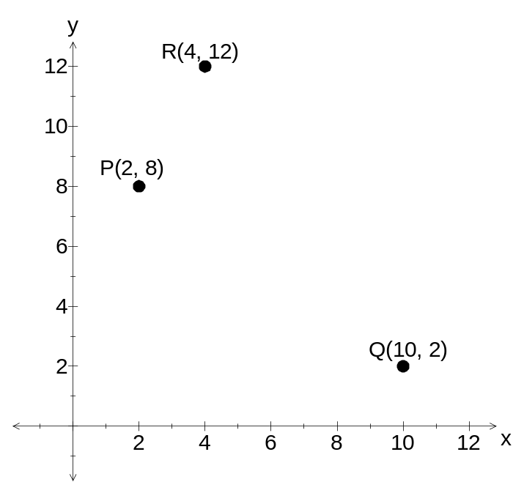

(a) Determine the exact coordinates of the midpoint M of PQ (1)

(b) Find the equation of the line perpendicular to PQ through the midpoint M. (4)

(c) Find the equation of the line RS given RS is parallel to PQ. (2)

(d) If P is the midpoint of NR, find the coordinates of N. (2)

(e) Determine the length of the line PQ. (2)
3. (7 marks)
Use the Venn Diagram below to determine
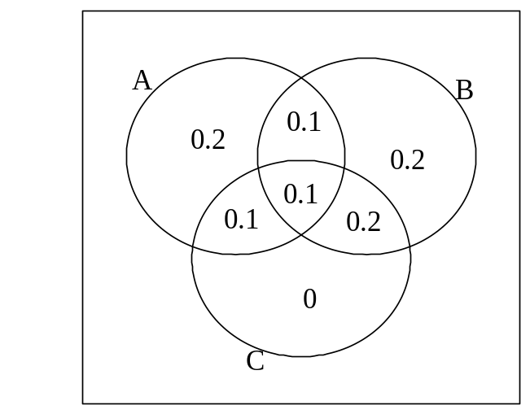

(a) 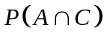 (1)

(b) 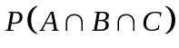 (1)

(c) 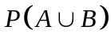 (1)

(d) 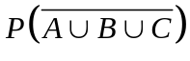 (2)

(e) 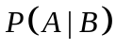 (2)

4. (5 marks)
Solve for x
(a) 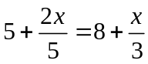 (3)

(b) 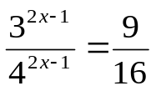 (2)

5. (8 marks)

A dog breeder has 60 dogs in his kennels. 40% of the dogs are Labradors, and all the rest are either Poodles or Dalmatians. There are half as many males as females, but only a quarter of the Poodles are male. There are 12 female Poodles and 3 male Labradors.

a) Complete the two-way table below. (3)

 | Poodle | Labrador | Dalmatian | Total
Male
Female
Total

b) What is the probability that a randomly chosen dog from this group will be?

- a Dalmatian? (1)

- a female Labrador? (1)

- either female or a Poodle? (1)

- a female, given that it is a Poodle? (2)

6. (4 marks)
(a) (i) Show that x-2 is a factor of the function 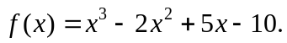 (1)

(ii) Hence by using long division, express  in the form: (2)

= (x-2) Q(x) + R

(b) Write down the centre and radius of the circle that has the equation
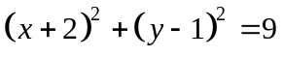 (1)

7. (6 marks)
(a) If 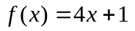 and 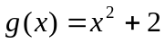

Find the following

(i) 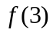 (ii) 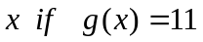 (2)

(b) State the domain and range for the function 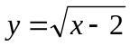 (2)

(c) A parabola has equation y= f(x) where f(x) = k(x - a)² + 16 where a is a constant
Find a and k if the parabola has a turning point at (2,16) and f (0) = -4 (2)

8. (4 marks)
Match the graphs drawn here with their corresponding equations from the set below the graphs:
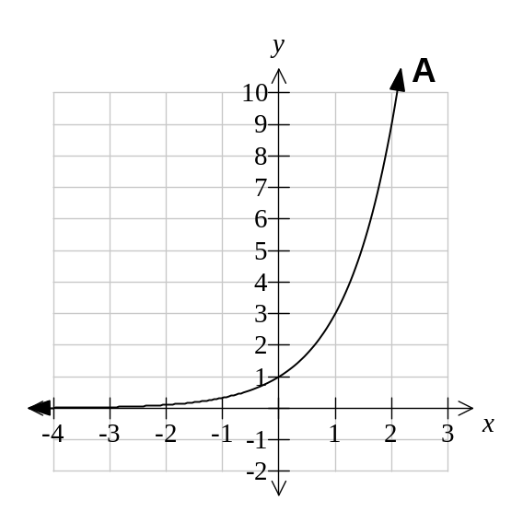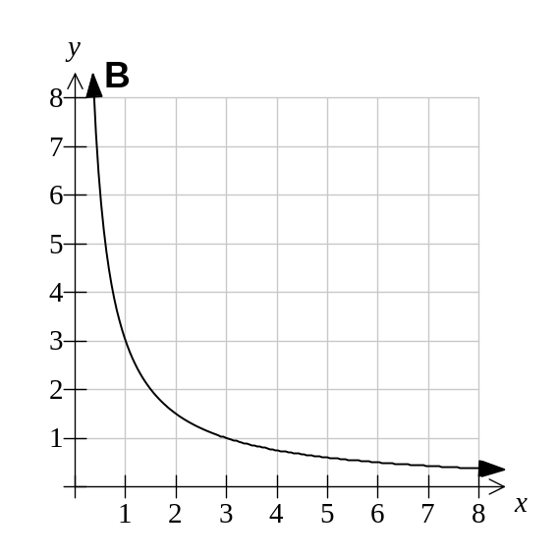

Graph A is equation: Graph B is equation:
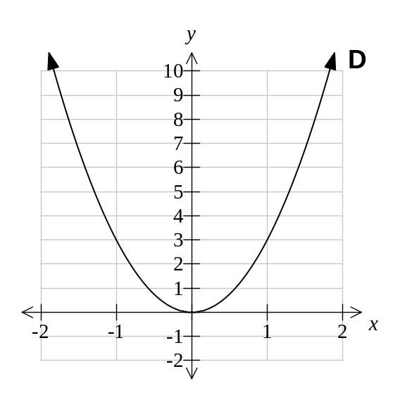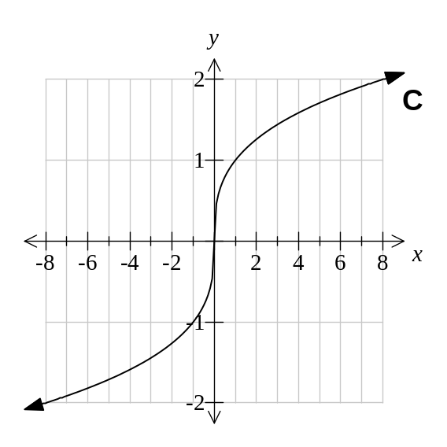

Graph C is equation : Graph D is equation:

Equations:
I : 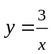 II: 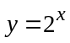 III: 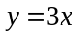 IV: 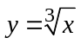

V: 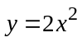 VI: 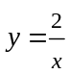 VII: 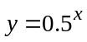 VIII: 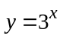

IX: 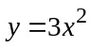 X: 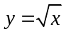 XI: 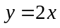 XII: 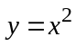

END OF SECTION ONE
Extra page for working if necessary

